

WELCOME

*to the*

NEUROSCIENCE

GRADUATE TRAINING PROGRAM

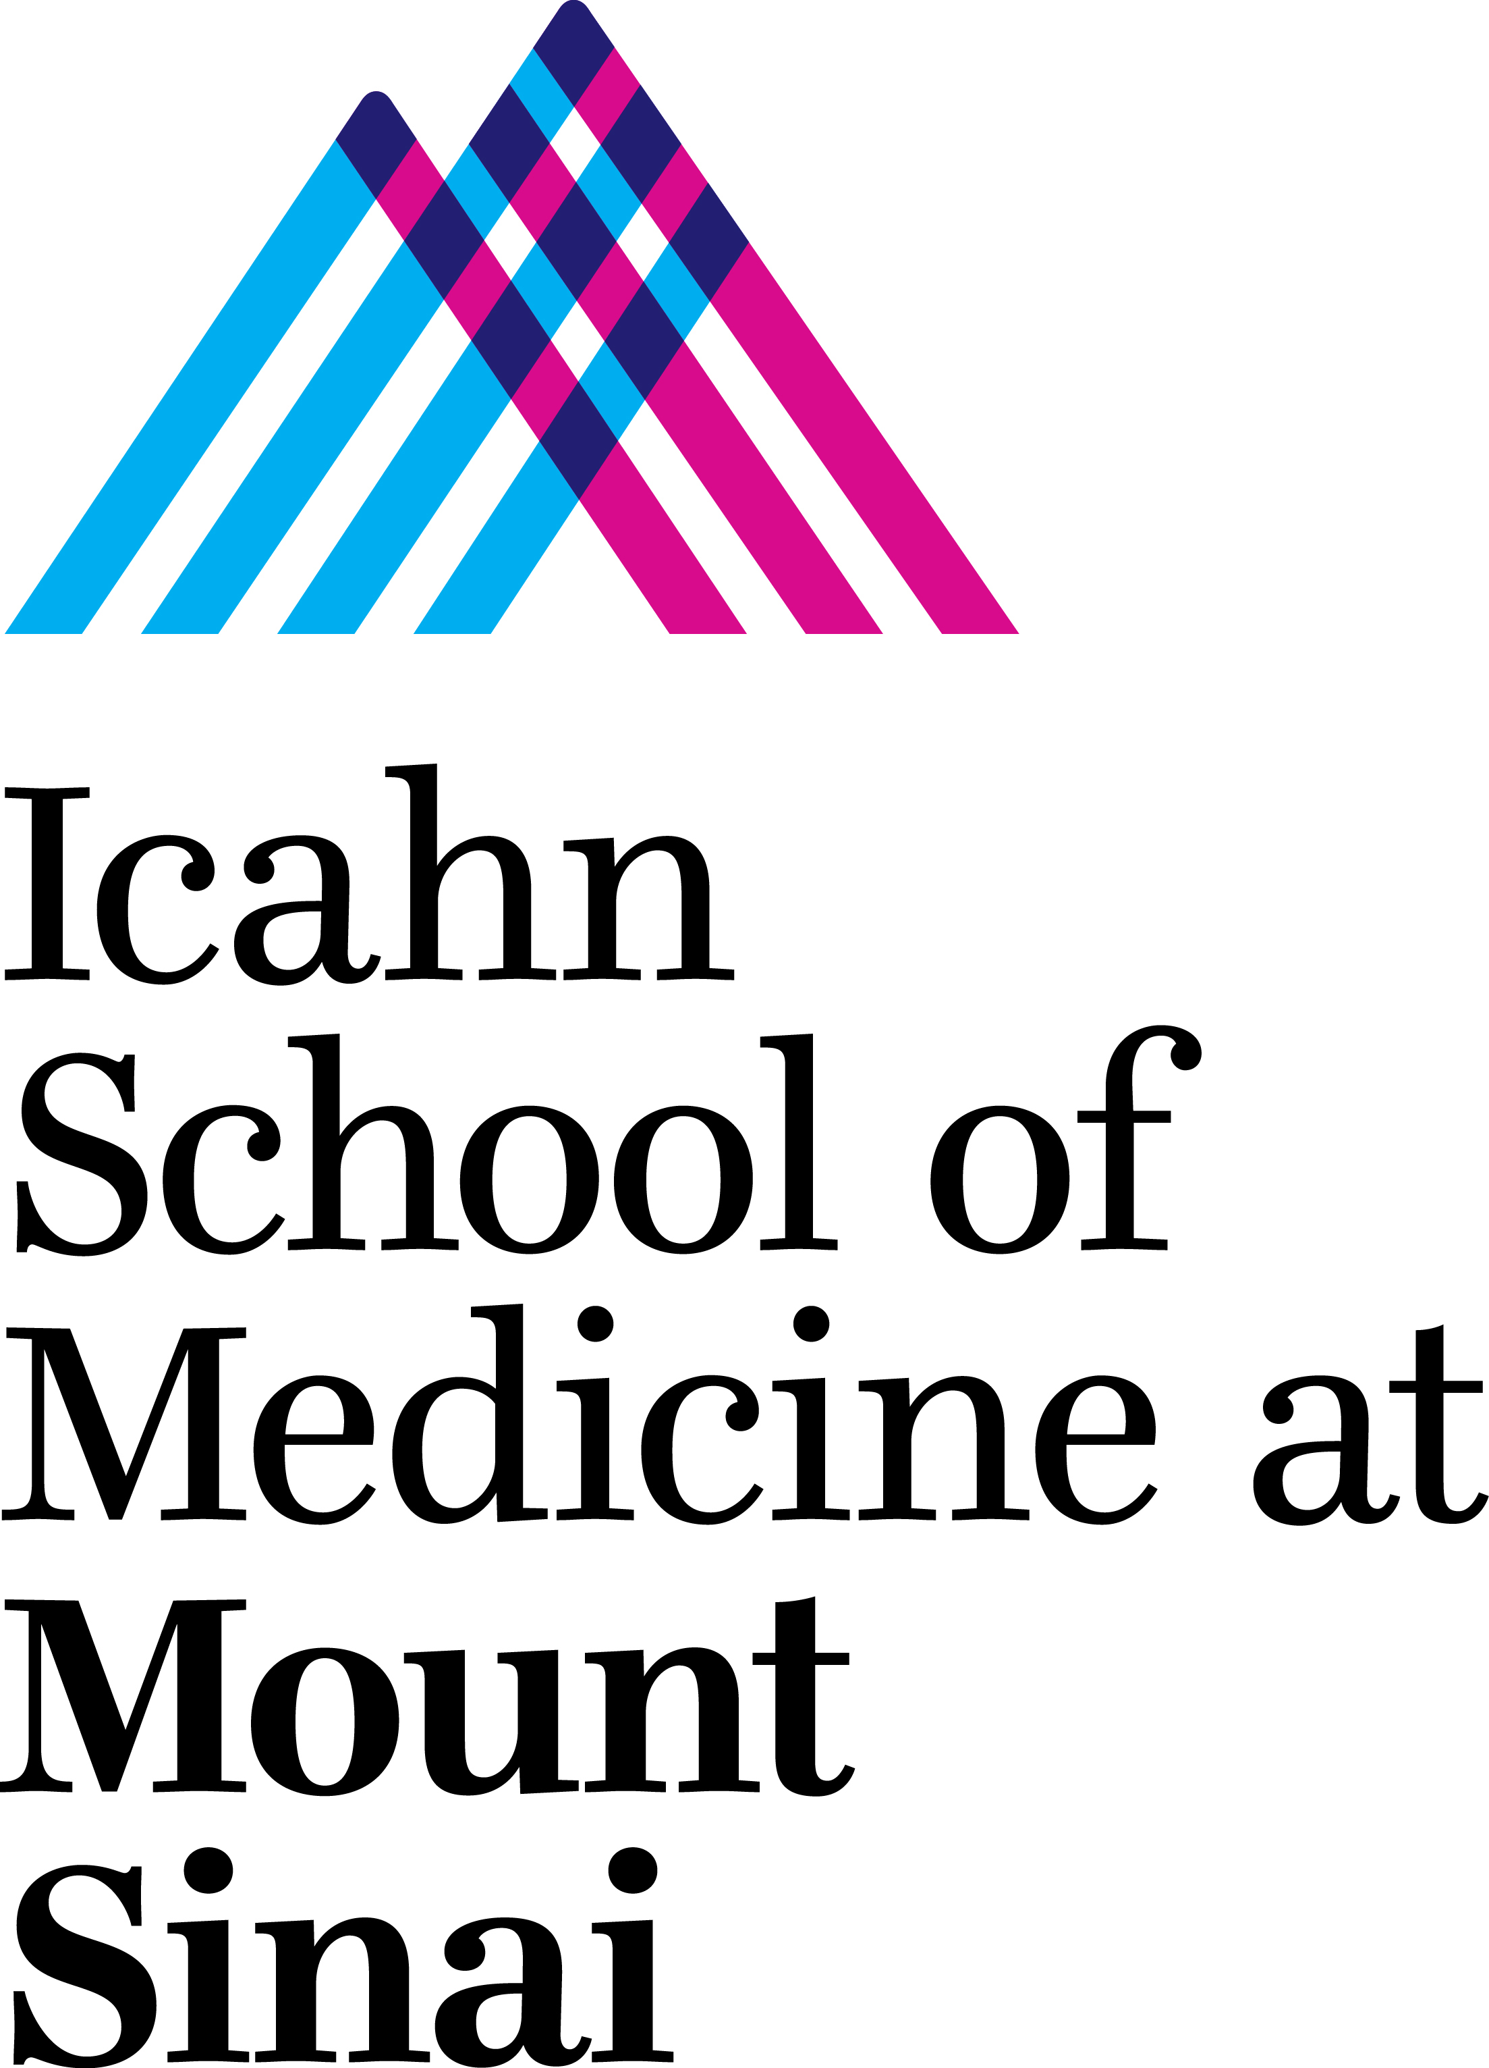

***WELCOME TO THE NEUROSCIENCE GRADUATE TRAINING PROGRAM!***

On behalf of the entire Neuroscience training faculty, we would like to welcome you to Mount Sinai and to the Neuroscience Multidisciplinary Training Area (MTA). We have prepared this "welcome letter" to help you familiarize yourself with the program and to give you a heads-up to what's coming down the road as you start your graduate training. All of this information will be repeated throughout the year and is also available on the Neuroscience training program [website](http://icahn.mssm.edu/education/phd/neuroscience).

**1. Courses**

For a listing of first- and second-year courses and what you should be registering for, [click here](https://labs.neuroscience.mssm.edu/wp-content/uploads/2023/11/1st-2nd-YEARS-WHAT-TO-REGISTER-FOR.pdf). Below is a brief outline of course requirements.

We have prepared a comprehensive Neuroscience Core course curriculum that you will take during your first year. The Core sequence comprises five separate courses designed to expose students from a wide range of backgrounds to principles of brain structure and function, spanning molecules, synapses, cells, circuits, behavior and disease. The five Core courses are: **Neuro Core 1**: *Systems Neuroscience* (BSR1706); **Neuro Core 2**: *Cellular and Molecular Neuroscience* (BSR 1705); **Neuro Core 3**: *Behavioral and Cognitive Neuroscience* (BSR 1708); **Neuro Core 4**: *Pathophysiology of Neurological and Psychiatric Disorders* (BSR1708) and **Neuro Core 5**: *Clinical Topics in Neuroscience* (BSR 6705). You must register for each Unit separately. Core 5 includes direct patient contact through exposure to patients presenting the disease or disorder that corresponds to the subject discussed simultaneously in Unit 4.

Additional course requirements during the first year include *Techniques and Approaches in Neuroscience*, *Responsible Conduct in Research*, *Rigor and Reproducibility*; *Selected Topics in Neuroscience* (a works-in-progress/journal club series), and *Seminar in Neurobiology*. Additionally, a Biostatistics requirement must be completed in Year 1. WE strongly encourage you to take “Modern Statistics for Modern Biology”, a specially designed spring Biostats course, although there are [other options](https://labs.neuroscience.mssm.edu/wp-content/uploads/2023/11/1st-2nd-YEARS-WHAT-TO-REGISTER-FOR.pdf) for fulfilling this requirement.

In Year 2, students are required to take *Neural Data Science*, an advanced biostatistics and neural computation course. Thereafter (anytime in years 2-4), PhD students are required to take a minimum of two advanced elective courses. This is an opportunity to customize your training by selecting advanced courses from any training area that will be of value to you. Check the website and the Registrar for current lists of advanced courses in Neuroscience, Computational Biology, Genetics and Genomics, Pharmacology, Cancer Biology or other training areas that may be of interest.

Students should register for "*Selected Topics in Neuroscience*" in Years 1-4+. Attendance is required for Year 1 and 2 students. Annual presentations are required for Year 2, 3 and 4+ students.

**2. Laboratory** [**Rotations**](https://labs.neuroscience.mssm.edu/rotation-guidelines/)

The goal of a rotation is to find a thesis laboratory. Students are required to complete laboratory rotations during their first year, and it is recommended that students complete two rotations of about 6-8 weeks each. If it is clear on either the part of the student or the PI that the rotation is not working, for whatever reason, the rotation can and should be ended after 3 weeks. Students should plan their rotations carefully: these are the labs that you are potentially interested in for your thesis work. As such, the goal of the rotation is to experience a prospective lab in terms of the kind of science it focuses on, the methods and approaches used, the lab "dynamic" between students, technicians, postdocs and the PI, etc. Conversely, the lab is experiencing you--are you the kind of colleague that would excel in and contribute to that environment? Picking a thesis lab ultimately requires mutual agreement between you and the PI. You should be aware that before accepting you for a rotation, preceptors MUST have at least two years of funding to support you should the rotation prove to be a match. While you are expected to be in the lab and work hard during your rotation, you are NOT expected to produce a finished study. PIs should be willing to give you time to prepare for your course exams. Please contact them directly to setup your rotations.

**3. Advisory committees**

All incoming first-year students are assigned a Neuroscience faculty advisor and a "big sibling", a more senior student in the program that can provide peer-to-peer guidance. Your advisor, your big sibling and the Neuroscience Training Area Director (Dr. Huntley) are the people to whom you can turn if you have questions, problems or need advice. After the first year, as the student advances toward completing their coursework, chooses a lab for their thesis work, and prepares to submit and defend their thesis proposal (see below for further details), a new committee (the Dissertation Advisory Committee) will be formed, generally consisting of three voting members and the thesis advisor (a non-voting member). Students are required by the Graduate School to meet with their Dissertation Advisory Committee every six months. The progress report of this advisory meeting, with sections compiled by the student, committee, and mentor, including a detailed student Individual Development Plan (IDP), needs to be completed, signed, and returned to the Graduate School.

**4. Preparing and defending your thesis proposal: the thesis proposal exam**

Students must assemble and defend their thesis proposal no later than June 30th of their 2nd year . By this time, rotations are finished, Core classes have been completed and you have identified a mentor who has agreed to support you in the laboratory for your thesis project. The thesis proposal document follows precisely the format of the Ruth L. Kirschstein NRSA (National Research Service Award), the NIH predoctoral fellowship (http://grants.nih.gov/grants/guide/pa-files/pa-11-111.html). Briefly, this is one-page for your Specific Aims, followed by a maximum of six-pages for Background and Significance, Preliminary Data and Research Strategy. References are not counted as part of the six-page limit (but figures are counted as part of the six-page limit). You are not required to have extensive preliminary data, but you should be able to demonstrate that your ideas are well-grounded and the methods you propose are appropriate and feasible. You will present your research plan to your thesis proposal exam committee in a formal oral presentation format. The Thesis Proposal Exam Committee consists of your 3-member Dissertation Advisory Committee, though an additional faculty member may be including if desired. Your preceptor must be present for this exam, but is a non-voting member. The dissertation advisory and thesis proposal committees are chosen by you and your preceptor. The idea is to pick committee members that have particular expertise--either conceptual or methodological--who can help you accomplish your scientific goals. You are not required to have the Neuroscience MTA director serve on your dissertation committee, but the Chair of your committee should be a senior, experienced faculty member. At the time when you defend your thesis work, your Dissertation Advisory Committee--plus one additional member from outside Mount Sinai--will serve as the final Thesis Defense examining committee.